Stage | Function | Name | Sign | Date
Originator | Production Engineer | Swapnaj Wadkar
Reviewers and Approvers | Manager QARA | Ashish Prabhudesai
Reviewers and Approvers | RA Specialist | Yogesh Dalvi

Revision History:

Revision No. | Changes | Author | Approved Date | Periodic Review Date
04 | Changed the label printing stationary of non-sterile products | SPJ | 05-Aug-2012 | N. A.
05 | Changed the address in the MRP label | SPJ | 10-Sep-2013 | N. A.
06 | Change the format to add the form number of labels, added country name in the address | SPJ | 16-May-2014 | N. A.
07 | Verification | SPJ | 01-July-2014 | N. A.
08 | Label printing with label format no, rev no & rev date, also add the label description & label material | SPJ | 31-Aug-2014 | N. A.
09 | Add the new barcode “GS1 > GTIN > EAN 13” on the main label format point no. 1 (from 1.1 to 1.6) , revision history added | SPJ | 07-Dec-2014 | 7-Dec-2015
10 | Added one “Syncera” label on each pouch of non-sterile products | SPJ | 01-April-2015 | 01-April-2016
11 | Changed date format. Previously it was YYYY-MM & now it is YYYY-MM-DD | SPJ | 24-Jan-2016 | 24-Jan-2017
12 | Changed the sterile date format. Previously the difference between sterile date & sterile expiry is four years & 11 months. Now it is five years. Form number LBL/F-01, LBL/F-02, LBL/F-03, LBL/F-04, LBL/F-10, LBL/F-11. | SPJ | 27-July-2016 | 27-July-2018
13 | Added new label format LBL/F-13_REV00_25AUG2016, HFN CE Marked Product, NON Sterile with Syncera logo  Remove the sterilization date from all sterile labels (LBL/F-01, LBL/F-02, LBL/F-03, LBL/F-04, LBL/F-10, LBL/F-11) based on the comments against FDA audit held at Adler MIDC factory on 10th Aug 2016. | SPJ | 25-Aug-2016 | 25-Aug-2018
14 | Based on the audit findings (External DNV audit held on 29th July 2016) include the following logo in the existing label of non-sterile products. (Label format number LBL/F-05, LBL/F-06, LBL/F-13).  Also modified point no 2.6 | SPJ | 22-Sept-2016 | 22-Sept-2018
15 | Remove manufacturing license number M.L.KD-469 from labels form no LBL/F-05, LBL/F-06, LBL/F-13 for groups Containers, External fixators, Instrument against RA requirement.  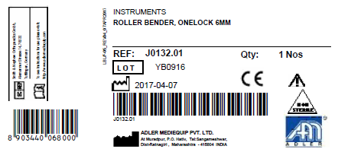 | SPJ | 07-APR-2017 | 07-APR-2019
16 | Removed old address as ADLER MEDIEQUIP PVT. LTD.  At Muradpur,P.O.Hativ,Tal. Sangameshwar, Dist. Ratnagiri, Maharashtra - 415804, INDIA  from the labels format number LBL/F-01, LBL/F-02, LBL/F-03, LBL/F-04, LBL/F-05, LBL/F-06, LBL/F-08, LBL/F-13 & added new address as ADLER MEDIEQUIP PVT. LTD.  Plot No. A-1, MIDC Sadavali, Tal. Sangameshwar, Dist. Ratnagiri, Maharashtra - 415804, INDIA ,revised label LBL/F-10 & LBL/F-11 | SPJ | 11-July-2017 | 10-July-2020
17 | Removed EC/REP instruction from label format LBL/F-05, LBL/F-06, LBL/F-13  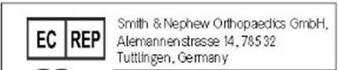  Added Sr.no.1.14 for details of EC/REP & IFU sticker, Added Sr.No.2.7 in placement details of label. | SPJ | 03-Aug-2017 | 02-Aug-2020
18 | Removed CE & CE0434 logo from label format LBL/F-01, LBL/F-02, LBL/F-03, LBL/F-05 & LBL/F-13 due to expiry of CE certificates. | SPJ | 16-Aug-2017 | 15-Aug-2020
19 | Adding the CE & CE0434 logo on label format LBL/F-05 & LBL/F-13 against RA requirement and new label format LBL/F-05A, LBL/F-13A, LBL/F-13B. | SPJ | 23-Aug-2017 | 22-Aug-2020
20 | CoO and GS1 barcode implement in label format LBL/F-13, LBL/F-13A and LBL/F-13B | SPJ | 16-Feb-2018 | 15-Feb-2021
21 | Revised label LBL/F-08, discontinued LBL/F-09 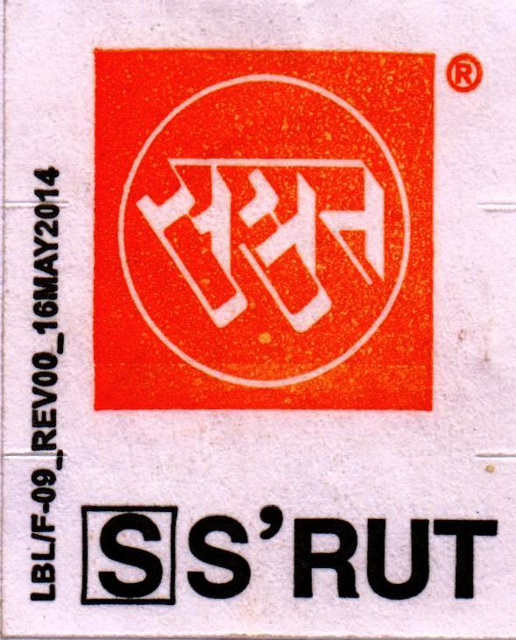  as per ECR E0200318 and renumbering of further Sr. No., and replaced Sr. No. 1.9 with CoO Sticker for Korean countries as per ECR E0200318.  Added LBL/F-15 & LBL/F-16 for new Restor RH family as per ECR E0010818 in Sr. No. 1.15 & 1.16, revised placement details of MRP label in Sr. No. 2.2., removed Sr. No. 2.3 for S’RUT label and renumbering of further Sr. No., and added placement details and applicability for “CoO Sticker” in Sr. No. 2.7 as per ECR E0200318. | SPJ | 04-Aug-2018 | 03-Aug-2021
22 | Revised label format LBL/F-13 as per ECR E0051118, E0060918  Revised label format LBL/F-10 and LBL/F-11 as per ECR E0160718  Revised label format LBL/F-08 as per ECR E0171018  Revised label format LBL/F06 as per ECR E0070818 | SDW | 28-Nov-2018 | 27-Nov-2021
23 | Revised label format LBL/F-16 as per ECR E0030319 | SDW | 09-APR-2019 | 08-APR-2022
24 | Change in reviewer. Translated to Marathi and added disclaimer as per DCR No. 090620 | SDW | 21JUL2020 | 20JUL2023
25 | Revised label format LBL/F-01, LBL/F-02, LBL/F-03, LBL/F-04, LBL/F-08, LBL/F-13, LBL/F-13B, LBL/F-15 by changing the drug license number and adding label dimensions and LBL/F-16 and remove label format LBL/F-05, LBL/F-05A, LBL/F-06, and LBL/F-12 as per ECR No. E0010421 | SDW | 12JUN2021 | 11JUN2024

Main Labels to be pasted on Products:
Sr. No | Criteria | Description | Sample Label
1.1 | Form No. | LBL/F-01_REV07_12JUN2021 | 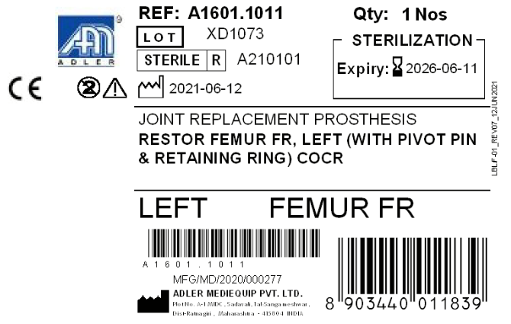
1.1 | Label Description | Sterile Product (Radiation Sterilised) Without Image
1.1 | Label Material | Maplitho Paper 70 to 75 GSM  Label Size: L=105mm X H=70mm  8 Labels in 1 A4 sticker paper
1.2 | Form No. | LBL/F-02_REV07_12JUN2021 | 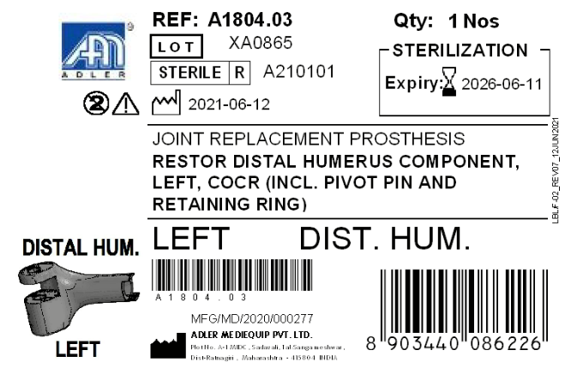
1.2 | Label Description | Sterile Product (Radiation Sterilised) With Image
1.2 | Label Material | Maplitho Paper 70 to 75 GSM  Label Size: L=105mm X H=70mm  8 Labels in 1 A4 sticker paper
1.3 | Form No. | LBL/F-03_REV07_12JUN2021 | 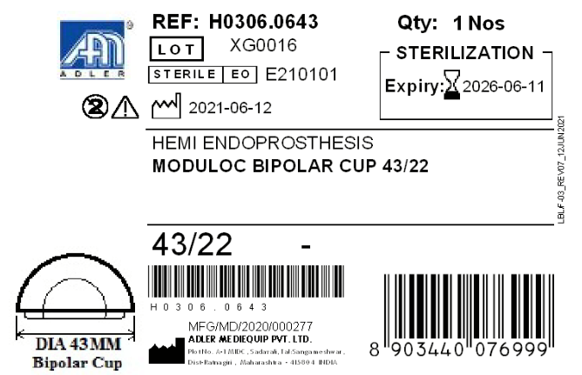
1.3 | Label Description | Sterile Product (ETO Sterilised) With Image
1.3 | Label Material | Maplitho Paper 70 to 75 GSM  Label Size: L=105mm X H=70mm  8 Labels in 1 A4 sticker paper
1.4 | Form No. | LBL/F-04_REV06_12JUN2021 | 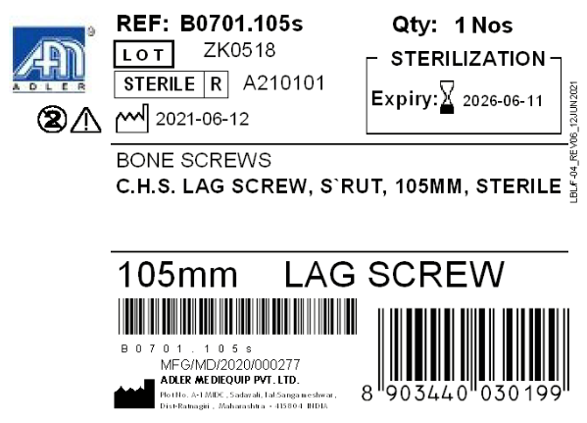
1.4 | Label Description | NON CE Marked Product Sterile (Radiation Sterilised)
1.4 | Label Material | Maplitho Paper 70 to 75 GSM  Label Size: L=105mm X H=70mm  8 Labels in 1 A4 sticker paper
1.7 | Form No. | LBL/F-07_REV00_16MAY2014 | 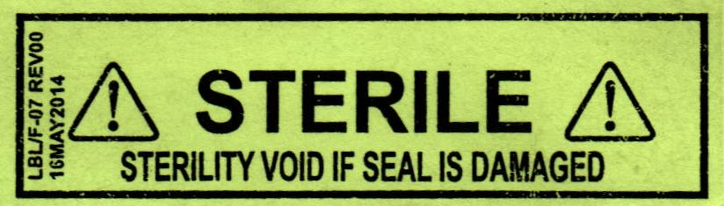
1.7 | Label Description | Sterile Seal
1.7 | Label Material | Maplitho Paper 70 to 75 GSM  Label Size: L=53mm X H=16mm  65 Labels in 1 - A4 sticker paper
1.8 | Form No. | LBL/F-08_REV04_12JUN2021 | 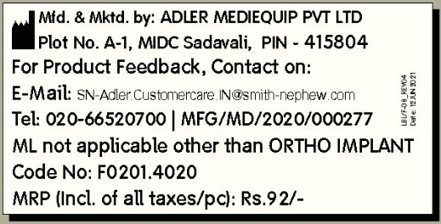
1.8 | Label Description | MRP Label
1.8 | Label Material | Sinnarmas Paper 70 to 75 GSM  Label Size: L=100mm X H=50mm  Labels in roll sticker paper
1.9 | Form No. | LBL/F-09_REV00_04AUG2018 | 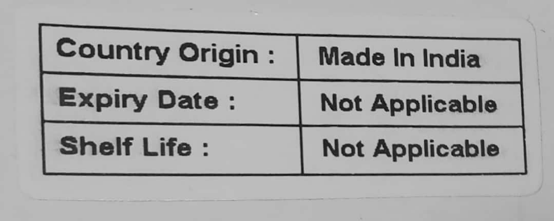
1.9 | Label Description | CoO Sticker
1.9 | Label Material | Chrome Paper 70 to 72 GSM  Label Size: L=50mm X H=20mm  Labels in roll sticker paper
1.10 | Form No. | LBL/F-10_REV05_24NOV2018 | 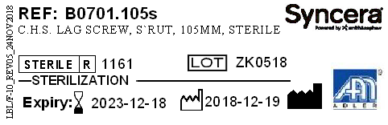
1.10 | Label Description | Patient Labels (Radiation Sterilised Products)
1.10 | Label Material | Maplitho Paper 70 to 75 GSM  Label Size: L=70mm X H=25mm  36 Labels in 1 A4 sticker paper
1.11 | Form No. | LBL/F-11_REV05_24NOV2018 | 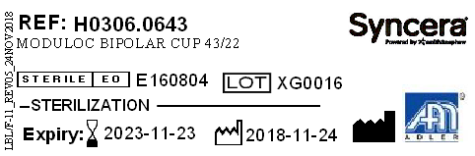
1.11 | Label Description | Patient Labels (ETO Sterilised Products)
1.11 | Label Material | Maplitho Paper 70 to 75 GSM  Label Size: L=70mm X H=25mm  36 Labels in 1 A4 sticker paper
1.13 | Form No. | LBL/F-13_REV09_12JUN2021 | 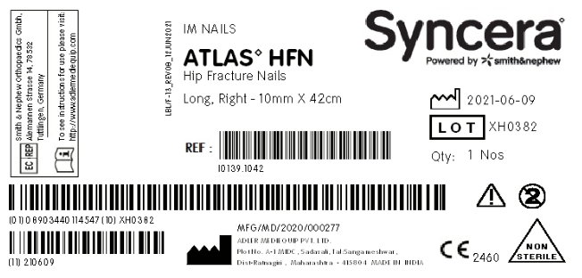
1.13 | Label Description | CE Marked Product, NON Sterile with Syncera logo with Notified Body number.
1.13 | Label Material | Maplitho Paper 70 to 75 GSM  Label Size: L=100mm X H=50mm  12 Labels in 1 A4 sticker paper
1.13A | Form No. | LBL/F-13A_REV01_16FEB2018 | 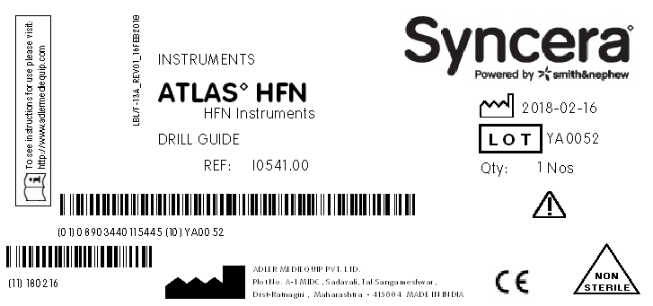
1.13A | Label Description | CE Marked Product, NON Sterile with Syncera logo without Notified Body number.
1.13A | Label Material | Maplitho Paper 70 to 75 GSM  Label Size: L=100mm X H=50mm  12 Labels in 1 A4 sticker paper
1.13B | Form No. | LBL/F-13B_REV02_12JUN2021 | 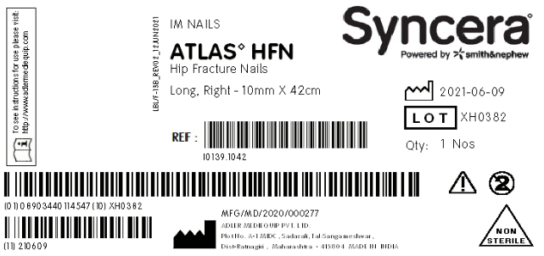
1.13B | Label Description | Non CE Marked Product, NON Sterile with Syncera logo.
1.13B | Label Material | Maplitho Paper 70 to 75 GSM  Label Size: L=100mm X H=50mm  12 Labels in 1 A4 sticker paper
1.14. | Form No. | LBL/F-14_REV00_03AUG2017
1.14. | Label Description | EC/REP & IFU Sticker
1.14. | Label Material | Chrome Paper 70 to 75 GSM  Label Size: L=50mm X H=20mm  Labels in roll sticker paper
1.15 | Form No. | LBL/F-15_REV01_12JUN2021 | 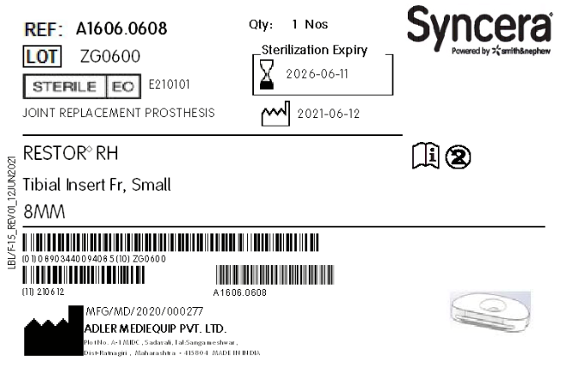
1.15 | Label Description | Sterile Product With Image
1.15 | Label Material | Maplitho Paper 70 to 75 GSM  Label Size: L=105mm X H=70mm  8 Labels in 1 A4 sticker paper
1.16 | Form No. | LBL/F-16_REV01_12JUN2021 | 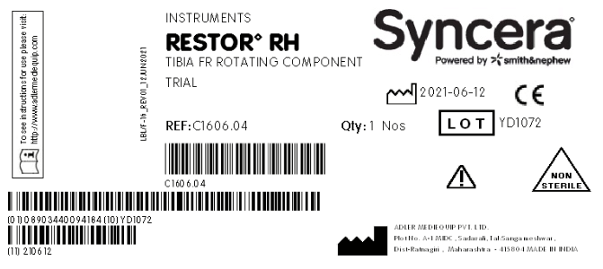  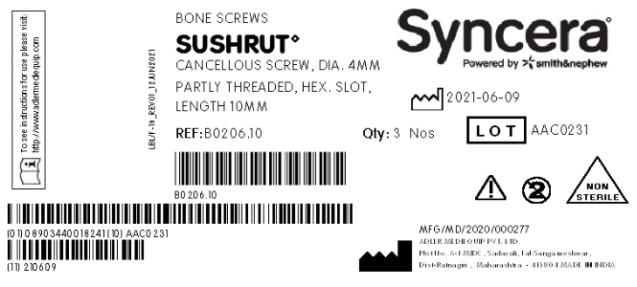
1.16 | Label Description | CE Marked Product for restor RH instruments and Non-CE marked products as per WI-ST/7, NON Sterile with Syncera  logo without Notified Body number.
1.16 | Label Material | Maplitho Paper 70 to 75 GSM  Label Size: L=100mm X H=50mm  12 Labels in 1 A4 sticker paper

Common Labels to be pasted on packaging as applicable:

Sr. No. | Label Name | Applicable to Products | Placement Details
2.1 | Sterile Seal | All Sterile Products | On at least one edge of the Protective Packaging (Outer Box)
2.2 | MRP Label | All Products Supplied in the Domestic / Indian Market | On backside for all non-sterile devices & above to product label for all sterile devices.
2.3 | Patient Labels | All Radiation Sterilized Products | Inside the Protective Packing of all Sterile Products
2.4 | Patient Labels | All ETO Sterilised Products | Inside the Protective Packing of all Sterile Products
2.5 | EC/REP & IFU sticker | This sticker should be pasted only on product which will be supply to EU countries. | Possibly on the top of box near MRP label, and on the top of the product’s pouches near product label or any suitable location nearby.
2.6 | CoO Sticker | This sticker should be pasted only on products which will be supplied to Korean countries. | Right side of the main product label or any suitable location nearby.

Disclaimer: This is a translation of the original English document in good Marathi made for the purpose of easy understanding by user. For any Legal / official / Audit purpose or in case of discrepancy, original version in English language should be considered valid.
अस्वीकरण: मूळ इंग्रजी दस्तऐवजाचे हे भाषांतर वापरकर्त्यांद्वारे समजून घेण्याच्या उद्देशाने चांगल्या मराठी भाषेत केले गेले आहे. कोणत्याही कायदेशीर / अधिकृत / ऑडिट हेतूसाठी किंवा काही फेरफार आढळल्यास इंग्रजी भाषेतील मूळ आवृत्ती हीच वैध मानली जाईल.

उत्पादनांवर मुख्य लेबले पेस्ट केली जातील :
Sr. No | Criteria | Description | Sample Label
1.1 | Form No. | LBL/F-01_REV07_12JUN2021
1.1 | Label Description | Sterile Product (Radiation Sterilised) Without Image
1.1 | Label Material | Maplitho Paper 70 to 75 GSM  Label Size: L=105mm X H=70mm  8 Labels in 1 A4 sticker paper
1.2 | Form No. | LBL/F-02_REV07_12JUN2021
1.2 | Label Description | Sterile Product (Radiation Sterilised) With Image
1.2 | Label Material | Maplitho Paper 70 to 75 GSM  Label Size: L=105mm X H=70mm  8 Labels in 1 A4 sticker paper
1.3 | Form No. | LBL/F-03_REV07_12JUN2021
1.3 | Label Description | Sterile Product (ETO Sterilised) With Image
1.3 | Label Material | Maplitho Paper 70 to 75 GSM  Label Size: L=105mm X H=70mm  8 Labels in 1 A4 sticker paper
1.4 | Form No. | LBL/F-04_REV06_12JUN2021
1.4 | Label Description | NON CE Marked Product Sterile (Radiation Sterilised)
1.4 | Label Material | Maplitho Paper 70 to 75 GSM  Label Size: L=105mm X H=70mm  8 Labels in 1 A4 sticker paper
1.7 | Form No. | LBL/F-07_REV00_16MAY2014
1.7 | Label Description | Sterile Seal
1.7 | Label Material | Maplitho Paper 70 to 75 GSM  Label Size: L=53mm X H=16mm  65 Labels in 1 - A4 sticker paper
1.8 | Form No. | LBL/F-08_REV04_12JUN2021
1.8 | Label Description | MRP Label
1.8 | Label Material | Sinnarmas Paper 70 to 75 GSM  Label Size: L=100mm X H=50mm  Labels in roll sticker paper
1.9 | Form No. | LBL/F-09_REV00_04AUG2018
1.9 | Label Description | CoO Sticker
1.9 | Label Material | Chrome Paper 70 to 72 GSM  Label Size: L=50mm X H=20mm  Labels in roll sticker paper
1.10 | Form No. | LBL/F-10_REV05_24NOV2018
1.10 | Label Description | Patient Labels (Radiation Sterilised Products)
1.10 | Label Material | Maplitho Paper 70 to 75 GSM  Label Size: L=70mm X H=25mm  36 Labels in 1 A4 sticker paper
1.11 | Form No. | LBL/F-11_REV05_24NOV2018
1.11 | Label Description | Patient Labels (ETO Sterilised Products)
1.11 | Label Material | Maplitho Paper 70 to 75 GSM  Label Size: L=70mm X H=25mm  36 Labels in 1 A4 sticker paper
1.13 | Form No. | LBL/F-13_REV09_12JUN2021
1.13 | Label Description | CE Marked Product, NON Sterile with Syncera logo with Notified Body number.
1.13 | Label Material | Maplitho Paper 70 to 75 GSM  Label Size: L=100mm X H=50mm  12 Labels in 1 A4 sticker paper
1.13A | Form No. | LBL/F-13A_REV01_16FEB2018
1.13A | Label Description | CE Marked Product, NON Sterile with Syncera logo without Notified Body number.
1.13A | Label Material | Maplitho Paper 70 to 75 GSM  Label Size: L=100mm X H=50mm  12 Labels in 1 A4 sticker paper
1.13B | Form No. | LBL/F-13B_REV02_12JUN2021
1.13B | Label Description | Non CE Marked Product, NON Sterile with Syncera logo.
1.13B | Label Material | Maplitho Paper 70 to 75 GSM  Label Size: L=100mm X H=50mm  12 Labels in 1 A4 sticker paper
1.14. | Form No. | LBL/F-14_REV00_03AUG2017
1.14. | Label Description | EC/REP & IFU Sticker
1.14. | Label Material | Chrome Paper 70 to 75 GSM  Label Size: L=50mm X H=20mm  Labels in roll sticker paper
1.15 | Form No. | LBL/F-15_REV01_12JUN2021
1.15 | Label Description | Sterile Product With Image
1.15 | Label Material | Maplitho Paper 70 to 75 GSM  Label Size: L=105mm X H=70mm  8 Labels in 1 A4 sticker paper
1.16 | Form No. | LBL/F-16_REV01_12JUN2021
1.16 | Label Description | CE Marked Product for restor RH instruments and Non-CE marked products as per WI-ST/7, NON Sterile with Syncera  logo without Notified Body number.
1.16 | Label Material | Maplitho Paper 70 to 75 GSM  Label Size: L=100mm X H=50mm  12 Labels in 1 A4 sticker paper

पॅकेजिंगवर पेस्ट करण्यात येणारी कॉमन लेबल:
Sr. No. | लेबल नाव | उत्पादनांना लागू | चिकटवण्याचा तपशील
2.1 | निर्जंतुकिकरण सील | सर्व निर्जंतुकीकरण उत्पादने | संरक्षणात्मक पॅकेजिंगच्या किमान एका काठावर (बाह्य बॉक्स)
2.2 | एमआरपी लेबल | देशांतर्गत / भारतीय बाजारात पुरवलेले सर्व उत्पादने | सर्व निर्जंतुकीकरण नसलेल्या साधनांच्या मागच्या बाजूला आणि वरील सर्व निर्जंतुकीकरण साधनांसाठी उत्पादनाच्या लेबलवर.
2.3 | रुग्ण लेबल | सर्व विकिरण निर्जंतुकीकरण उत्पादने | सर्व निर्जंतुकीकरण उत्पादनांचे संरक्षणात्मक पॅकिंग आत
2.4 | रुग्ण लेबल | सर्व ETO निर्जंतुकीकरण उत्पादने | सर्व निर्जंतुकीकरण उत्पादनांचे संरक्षणात्मक पॅकिंग आत
2.5 | EC / REP आणि IFU स्टिकर | हे स्टिकर केवळ अशा उत्पादनावर पेस्ट केले जावे जे EU देशांना पुरवले जाईल. | शक्यतो एमआरपी लेबल जवळ बॉक्सच्या शीर्षस्थानी आणि उत्पादनाच्या लेचच्या जवळच्या उत्पादनाच्या शीर्षस्थानी किंवा जवळपास कोणत्याही योग्य ठिकाणी.
2.6 | CoO स्टिकर | हे स्टिकर केवळ कोरियन देशांना पुरविल्या जाणार्‍या उत्पादनांवरच पेस्ट केले पाहिजे. | मुख्य उत्पाद लेबलच्या उजवीकडे किंवा जवळील कोणत्याही योग्य ठिकाणी.

